User Support Project

Submitted to: Prof. Anoop Saxena

Submitted by: TEAM-3

(Arshdeep Singh, Irwin Preet Kaur, Shreyas Dutt, Gursher Singh)

Table of Contents

Table of Figures 2

Product Name 2

About the product 2

Environment Description 3

Types of user support being provided by Lenovo ThinkPad 5

Potential problems/issues faced by users 6

Problem-solving strategies 7

Flowcharts 9

Script for Malfunctioning Keyboard 17

Script for Wi-Fi Connectivity Problem 17

Script for Device not Charging 17

Script for BIOS Updating 18

Script For Laptop Unable to Connect to Usb Devices 18

Script for Laptop Overheating 19

Script for Graphics Card (GPU) not working 20

Script for Bluetooth not working 22

Escalation arrangement 23

Tools to support/enhance the user experience. 24

# Table of Figures

Figure 1 Malfunctioning Keyboard 9

Figure 2 Wi-Fi Connectivity Problem 10

Figure 3 Device not charging 11

Figure 4 Bios Updating 12

Figure 5 USB not connecting 13

Figure 6 Laptop Overheating 14

[Figure 7 GPU not Working 15](https://d.docs.live.net/82b6ebc976bf76cc/Desktop/New%20CIS-285%20User%20Support.docx#_Toc151321151)

Figure 8 Bluetooth not working 16

# Product Name

Lenovo ThinkPad Series

# About the product

The Lenovo ThinkPad is a preferred option, for multiple different environments due, to its durability and advanced features. It enables professionals to enhance their productivity across a range of business tasks.

# Environment Description

1. Physical Environment:

Location: The support center is in a central and easily accessible area.

Workspace Setup: The center features a well-organized workspace with designated areas for different functions.

Lighting and Ergonomics: Adequate lighting and ergonomic furniture contribute to a comfortable working environment.

1. Employee Positions:

Customer Support Representatives: Responsible for handling customer inquiries, troubleshooting, and providing solutions.

Technical Specialists: Experts in diagnosing and resolving complex technical issues.

Supervisors/Managers: Oversee operations, handle escalations, and ensure smooth workflow.

1. Equipment:

Workstations: Each employee has a dedicated workstation equipped with a computer and necessary peripherals.

Diagnostic Tools: Specialized tools and software for diagnosing and resolving laptop issues.

Communication Tools: Headsets, phones, and video conferencing tools for effective communication.

1. Surrounding Environment:

Quiet Zones: Designated areas for tasks requiring concentration and minimal distractions.

Collaboration Areas: Spaces for team collaboration and knowledge sharing.

Training Room: A dedicated space for employee training and skill development.

1. Contact Methods:

Phone Support: Customers can reach the support center through a dedicated helpline for immediate assistance.

Live Chat: Real-time chat support is available on the official website for quick queries.

Email Support: Customers can email their concerns, and support representatives will respond within a specified timeframe.

1. Service Delivery:

Remote Assistance: Technicians can remotely access customers' laptops to diagnose and resolve issues efficiently.

In-Person Support: For more complex problems, the support center provides options for in-person assistance at authorized service centers.

Self-Help Resources: A comprehensive online knowledge base with FAQs, guides, and troubleshooting articles for customers to find solutions independently.

1. Response Time and Service Level Agreements (SLAs):

Guaranteed Response Times: Clearly defined response times for different types of inquiries.

SLAs for Issue Resolution: Defined timelines for resolving customer issues, ensuring a prompt and efficient service.

1. Continuous Improvement:

Feedback Mechanism: Regular customer feedback is collected to identify areas for improvement.

Training Programs: Ongoing training programs for employees to stay updated on new laptop models and technologies.

# Types of user support being provided by Lenovo ThinkPad

1. Technical Support: Lenovo offers assistance for troubleshooting technical issues, diagnosing hardware or software problems, and guiding users through the resolution process.
2. Warranty Services: Various warranty packages cover hardware defects and issues within specified periods, providing repair, replacement, or service options for eligible problems.
3. Online Support Resources: Lenovo's extensive online knowledge base, FAQs, user manuals, and software downloads offer users guidance in resolving common issues and understanding product features.
4. Driver and Software Updates: Regular updates are provided for drivers and software to ensure access to the latest features, bug fixes, and security patches for ThinkPad devices.
5. Product Documentation: Comprehensive documentation, including user guides, setup instructions, and specifications, assists users in maximizing their experience with ThinkPad laptops.
6. Community Forums: Online communities and forums enable users to seek advice, share experiences, and find solutions by interacting with other users and, sometimes, Lenovo support staff.
7. On-site Services: Certain warranty packages or service contracts may include on-site support, where Lenovo technicians visit the user's location to resolve technical issues.
8. Extended Support Services: Lenovo offers additional coverage beyond the standard warranty period, such as extended warranties, accidental damage protection, or additional technical assistance.

# Potential problems/issues faced by users

1. Driver and Software Issues: Users may experience difficulties with drivers or software, such as compatibility problems, bugs, or issues arising from software updates.
2. Hardware Problems: This can include malfunctions with components like the keyboard, trackpad, screen, or battery, which might require replacement or repair.
3. Overheating: Some users might face issues related to overheating, particularly during intensive tasks, potentially impacting performance or causing the laptop to shut down unexpectedly.
4. Performance Degradation: Over time, users might notice a decrease in system performance due to various factors like aging hardware, accumulation of software, or other reasons.
5. Connectivity Problems: Issues related to Wi-Fi, Bluetooth, or other connectivity features may arise, resulting in unreliable or disrupted connections.
6. Battery Life Issues: Users might experience shorter battery life than expected, which could be due to aging batteries, excessive background processes, or other factors.
7. Screen or Display Problems: Users might encounter issues like screen flickering, dead pixels, or display artifacts affecting the visual experience.
8. Noise or Fan Issues: Some users might notice excessive fan noise or irregular behavior, which can be related to cooling system inefficiencies or hardware problems.
9. Physical Wear and Tear: This can involve wear on external components, hinges, or ports due to extensive use, potentially affecting the device's durability and appearance.
10. Software Compatibility: Users may face challenges related to software compatibility with certain applications or operating systems, leading to operational issues or limitations.
11. Security Concerns: Occasionally, users might encounter security vulnerabilities or concerns, requiring prompt updates or patches to address potential threats.

# Problem-solving strategies

1. Update Drivers and Software: Regularly update drivers and system software. Lenovo's website often provides updated drivers and patches to fix compatibility issues and bugs.
2. Troubleshooting Guides: Use manufacturer-provided troubleshooting guides or user manuals to address common issues. These guides often offer step-by-step solutions.
3. Hardware Diagnostics: Utilize built-in diagnostic tools or third-party software to identify and address hardware issues. Lenovo provides diagnostic tools for ThinkPad laptops.
4. System Maintenance: Perform routine maintenance, such as disk cleanup, defragmentation, and system optimization, to improve performance and prevent software-related issues.
5. Cooling and Thermal Management: Ensure proper ventilation and use cooling pads to prevent overheating issues. Check for dust accumulation in the system's fans and vents.
6. Battery Calibration and Management: Calibrate the battery periodically and manage power settings to optimize battery life. Consider replacing the battery if it's degraded.
7. Screen Calibration and Inspection: Adjust screen settings and run diagnostic tests to identify and fix display-related problems. Contact support if there are persistent issues.
8. Connectivity Troubleshooting: Troubleshoot connectivity issues by restarting the device, updating drivers, and checking network settings. Test connections on different networks.
9. Noise and Fan Control: Adjust power settings to manage fan speed or install software for controlling fan behavior. Ensure the laptop is placed on a flat, stable surface for proper airflow.
10. Physical Maintenance: Regularly clean the laptop to prevent dust buildup, and handle it carefully to avoid physical damage.
11. Software Compatibility Solutions: Look for updated software versions or patches to improve compatibility. Additionally, consider alternative software solutions or workarounds.
12. Security Updates: Ensure the laptop has the latest security updates installed to address potential vulnerabilities. Regularly update antivirus software for added protection.

# Flowcharts

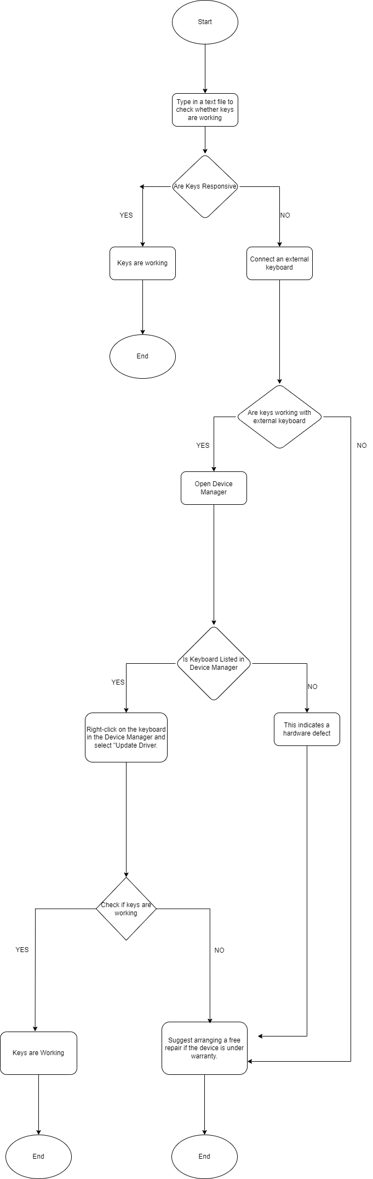

Figure 1 Malfunctioning Keyboard

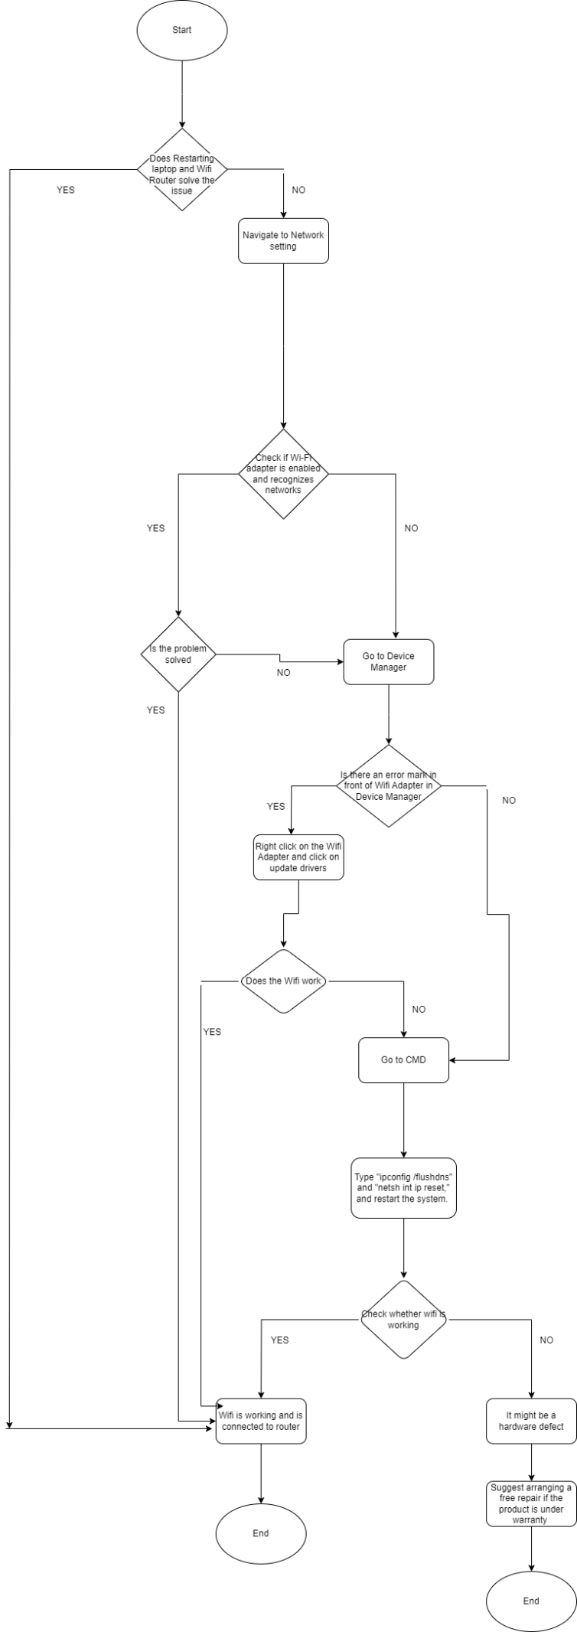

Figure 2 Wi-Fi Connectivity Problem

Figure 3 Device not charging

Figure 4 Bios Updating

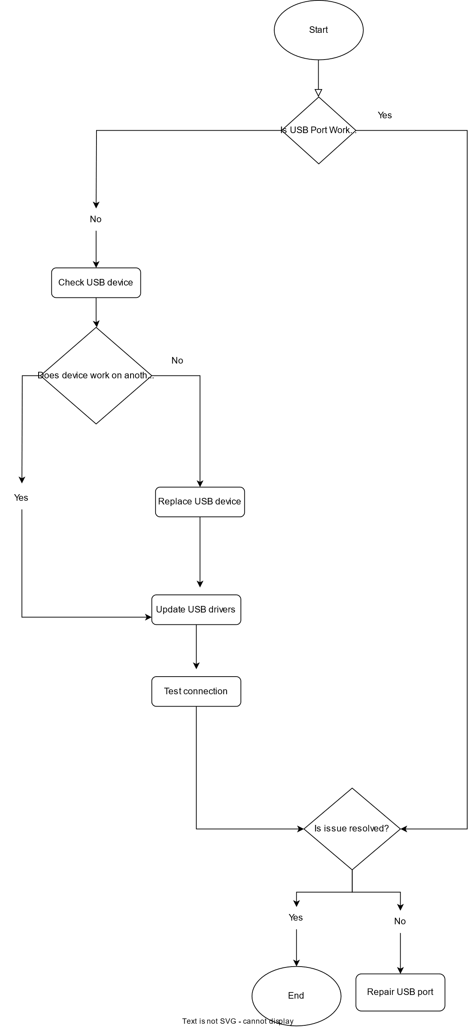

Figure 5 USB not connecting

Figure 6 Laptop Overheating

Figure GPU not Working

Figure 8 Bluetooth not working

# Script for Malfunctioning Keyboard

1. Open a text document and attempt to type using the keys that are not responding.
2. If the keys are still unresponsive, connect an external keyboard to determine if the issue is specific to the internal keyboard.
3. Check the Device Manager to confirm the status of the keyboard driver.
4. If the keyboard is not listed, it may indicate a hardware defect or improper connection to the motherboard. If it is listed without errors, proceed to update the drivers.
5. Right-click on the keyboard in the Device Manager and choose "Update Driver."
6. After updating the driver, check if the keyboard is functioning properly. If the issue persists, and your device is under warranty, we will arrange for a free repair.

# Script for Wi-Fi Connectivity Problem

1. To resolve the issue, try restarting the laptop and the Wi-Fi router.
2. If the problem persists, navigate to the network settings on your laptop.
3. Check if the Wi-Fi adapter is enabled and if Wi-Fi is turned on, recognizing available networks.
4. If Wi-Fi is ON but not showing networks, outdated drivers might be the issue.
5. Go to Device Manager to check the status of the Wi-Fi adapter. Look for any error symbols.
6. If you see an error symbol, right-click on the Wi-Fi adapter and select "Update Drivers."
7. Check if the issue is resolved. If it persists, open the Command Prompt as an administrator, type "ipconfig /flushdns" and "netsh int ip reset," then restart the computer.

# Script for Device not Charging

1. Ensure that your device is connected to a power source. If not, please connect it to a power outlet.
2. Verify the functionality of the display. If it's working correctly, you can conclude the troubleshooting process. If not, proceed to the next step.
3. Instruct the user to restart the laptop and check if the issue persists.
4. After the restart, reassess the persistence of the issue. If the problem persists, initiate the Lenovo Inbuilt Diagnostics Test.
5. If the diagnostics test indicates a functional display, conclude the troubleshooting. If the screen is physically damaged and the diagnostics screen is not visible, ask about its visibility.
6. If visible, proceed with the test and share the results. If not visible, categorize it as a hardware issue and recommend contacting the nearest service centre for replacement or repair.
7. If the Diagnostics Result points to a display issue, flag it as a formal complaint.
8. If no display issues are identified through diagnostics, proceed to update the Display Drivers/Graphics Drivers.
9. After updating the drivers, recheck the display's functionality. If the issue is resolved, conclude the troubleshooting. If not, escalate the problem by filing a formal complaint.

# Script for BIOS Updating

1. Begin by asking the user if they have the Lenovo Vantage Application on their Lenovo laptop.
2. If the application is present, guide the user to run the system Update Scan. If not, assist them in installing it from the Microsoft Store, and then proceed with the test.
3. Check for BIOS updates and click on "Install."
4. A prompt will appear, indicating a reboot is required. Click "OK."
5. Ask the customer if their laptop is connected to a power source. If yes, select "Install" in the Flash Update Utility. If not, instruct them to connect to a power source.
6. Click "Yes" to begin the update.
7. The update will be installed automatically, and your laptop will restart on its own.
8. End the troubleshoot when the BIOS is successfully installed.

# Script For Laptop Unable to Connect to Usb Devices

TS (Tech Support) : Hi, this is Alex from Lenovo technical support. How can I assist you today?

User: Hi, I'm having problems with my laptop's USB connectivity.

TS: I'm here to help. Let's troubleshoot together. First, is your laptop connected to a power source?

User: Yes, it is.

TS: Great. Now, let's focus on the USB issue. Are you able to connect any USB device, like a flash drive or an external hard drive?

User: No, none of the USB devices seem to be working.

TS: Okay, let's isolate the problem. Can you try connecting those USB devices to another laptop or computer to see if they work there?

User: Sure, just a moment. Done, the USB devices aren't working on the other laptop either.

TS: That suggests the issue might be with the USB devices themselves. Have you tried replacing the USB cables or using different ports on your laptop?

User: Yes, I’ve tried different cables and ports, but they still don’t work.

TS: Understood. Let's update the USB drivers on your laptop. Go to the Device Manager, locate the USB controllers, right-click, and select "Update Driver Software."

User: Alright, I'll do that. Done updating the drivers.

TS: Great! Could you test the USB devices again and see if they're now recognized?

User: Oh, everything is working fine now. The devices are connecting without any issues!

TS: Fantastic! Updating the drivers often resolves connectivity problems. If you encounter any further issues, don't hesitate to reach out to us for assistance.

User: Thanks a lot for your help.

TS: You're welcome! If you need anything else, feel free to contact us. Have a wonderful day!

User: You too!

# Script for Laptop Overheating

User: Hi, I think my laptop might be overheating.

TS (Tech Support): Alright, let's check that. Can you hear the fan running or feel the airflow from the vents?

User: No, I don’t hear anything.

TS: In that case, it might be a fan issue. First, shut down the laptop to prevent further overheating. Let it cool down for a while.

User: Okay, it’s turned off now.

TS: Perfect. While it cools down, have you noticed any dust accumulation around the vents or fan area?

User: Not really, but I haven’t cleaned it in a while.

TS: Dust can cause overheating. Once it's cooled, use compressed air to clean the fan and vents. Be gentle to avoid damaging anything.

User: Got it. Should I turn it on after cleaning?

TS: Yes, turn it on and monitor its temperature while doing regular tasks. If it stays cool, you should be good to go.

User: Alright, I'll try that. What if it's still overheating?

TS: If it still overheats after cleaning or if the fan isn’t working, it might need professional attention. Stop using it and contact technical support or a repair centre.

User: Understood. Thanks for the help!

TS: No problem! If you have any other questions, feel free to ask.

# Script for Graphics Card (GPU) not working

Person 1 (User): Hey, I’ve been having some issues with my GPU. Can you help me troubleshoot it?

TS (Tech Support): Of course! Let’s start by checking a few things. Have you noticed any specific problems or error messages?

Person 1: Yeah, my monitor sometimes goes black randomly, especially when I’m running graphic-intensive applications.

TS: Alright. First, ensure that the GPU is seated correctly in the PCIe slot on your motherboard. Have you made any recent hardware changes?

Person 1: No, I haven’t. But I’ll double-check the connections and make sure everything is snug.

TS: Good. Additionally, have you updated your GPU drivers recently?

Person 1: I don’t think so. Should I update them now?

TS : Yes, definitely. Visit the manufacturer’s website and download the latest drivers for your GPU model. After that, perform a clean installation to rule out any software conflicts.

Person 1: Alright, I’ll do that. Should I also check for overheating issues?

TS: Absolutely. Monitor your GPU temperatures using software like MSI Afterburner or GPU-Z. Ensure that the fans on your GPU are running properly and aren’t obstructed by dust or debris.

Person 1: Okay, I’ll keep an eye on that. Is there anything else I should do?

TS: Yes, try running stress tests to check for stability under load. This will help determine if the issue occurs during heavy usage.

Person 1: Got it. If these steps don’t work, what should I do next?

TS: If the problem persists, it might be worth testing the GPU in another system to see if the issue follows. If it does, it could indicate a hardware problem. You might want to consider contacting the manufacturer’s support or a professional technician for further assistance.

Person 1: Okay, I’ll try these steps and reach out for help if needed. Thanks a lot for your guidance!

TS: You’re welcome! Don’t hesitate to ask if you need more help. Good luck!

# Script for Bluetooth not working

TS (Tech Support) : Hey, I'm having trouble with my laptop's Bluetooth. It's not connecting to my headphones.

Person 2 (User): Oh, that's frustrating. Let's try a few steps to troubleshoot the issue. Have you checked if the Bluetooth is turned on?

TS: Yeah, I made sure it's on. But it's still not detecting any devices.

Person 2: Alright, let's start by restarting the Bluetooth services. Go to the Device Manager by pressing Win + X and select "Device Manager."

TS: Okay, I'm in Device Manager. Where should I go from here?

Person 2: Expand the "Bluetooth" section, right-click on your Bluetooth device, and select "Disable device." Wait a few seconds and then right-click again to "Enable device."

TS: Done. Should I try connecting the headphones now?

Person 2: Not yet. Let's also update the Bluetooth drivers. Right-click on the Bluetooth device again, select "Update driver," and choose "Search automatically for updated driver software."

TS: Alright, it's updating. What's next?

Person 2: While that's updating, let's check the Bluetooth settings. Press Win + I for Settings, then go to "Devices" and select "Bluetooth & other devices." Ensure Bluetooth is on and set your laptop to be discoverable.

TS: The drivers are updated, and Bluetooth is on, but it's still not working.

Person 2: Let's run the Bluetooth troubleshooter. Go to Settings > Update & Security > Troubleshoot. Scroll down and select "Bluetooth." Click on "Run the troubleshooter" and follow the prompts.

TS: Okay, it's identifying the problem.

Person 2: While that's running, let's also check the power management settings for the Bluetooth device. Right-click on the device in Device Manager, go to "Properties," and uncheck "Allow the computer to turn off this device to save power" in the "Power Management" tab.

TS: The troubleshooter finished, but it didn't fix the issue.

Person 2: Let's try removing and re-pairing the headphones. Go back to Settings > Devices > Bluetooth & other devices. Remove the headphones and try reconnecting them.

TS: Okay, removed and re-paired, but still no luck.

Person 2: It seems we've exhausted the basic troubleshooting steps. Perhaps it's a deeper issue. I'd recommend contacting the laptop manufacturer's support for further assistance. They might have additional steps or solutions tailored to your specific device.

TS: Alright, I'll reach out to them. Thanks for trying to help!

# Escalation arrangement

## Level 1 – User Guidance and Basic Troubleshooting:

* Objective: Address and resolve user-reported issues promptly.

Process:

* Initiate user inquiry to comprehend the problem.
* Provide preliminary assistance through accessible user manuals or guides.
* Engage with customers to gather crucial issue details.
* Apply basic troubleshooting using established solutions within the system.
* Escalate unresolved issues to Level 2 support.

## Level 2 - Technical Support Specialist:

* Objective: Conduct advanced technical analysis to resolve complex issues.

Process:

* Perform in-depth analysis of technical issues for effective problem-solving.
* Utilize specialized tools and knowledge for advanced diagnostics.
* Develop and implement solutions to address intricate problems.
* Escalate persistent issues to Level 3 support.

## Level 3 - Manufacturer Support:

* Objective: Collaborate with the manufacturer for issue resolution and hardware support.

Process:

* Engage with the manufacturer's tech support for efficient issue resolution.
* Gather and provide relevant information to facilitate troubleshooting and resolution.
* Coordinate necessary hardware repairs or replacements as advised.

## Additional Procedures

Detailed Case Documentation:

* Maintain thorough case records to track progress and facilitate learning.
* Log issues in a centralized knowledge base for efficient future escalations to enhance customer experience.

# Tools to support/enhance the user experience.

* Ensure that customers can easily get in touch with support. Make sure to provide straightforward contact details on your website and, in the product documentation.
* A ticketing system is a software tool that assists in managing customer support tickets. It enables the tracking of tickets assigning them to agents and setting priorities. A designed ticketing system should be user-friendly, for both customers and agents. By implementing a ticketing system you can effectively. Handle customer support tickets ensuring that all issues are promptly and efficiently addressed.
* Gathering feedback, from customers through customer satisfaction surveys is another practice. This feedback allows you to pinpoint areas where you can enhance the user support experience.
* Make sure to check in with customers after resolving their issues. This demonstrates that you genuinely value their satisfaction and are dedicated to delivering the user support experience.